**MAY MASAKIT**

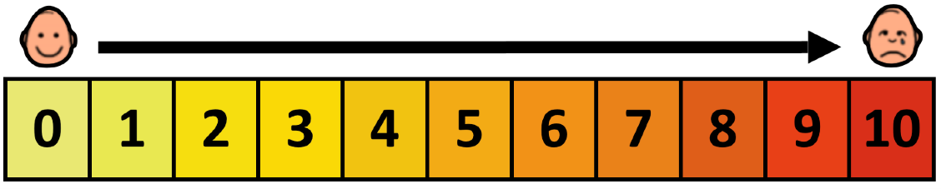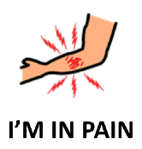

|  |  |  |  |
| --- | --- | --- | --- |
| **Walang Masakit** | **Kaunting Sakit** | **Medyo Masakit** | **Sobrang Sakit** |
| **No pain** | **Mild pain** | **Moderate pain** | **Intense pain** |
|  |  |  |  |

|  |  |  |  |  |  |
| --- | --- | --- | --- | --- | --- |
| **ULO**  **HEAD** | **LALAMUNAN**  **THROAT** | **DIBDIB**  **CHEST** | **TIYAN**  **STOMACH** | **LIKOD**  **BACK** | **BRASO**  **ARMS** |
| **KAMAY**  **HANDS** | **BALAKANG**  **HIP** | **PWET**  **BACKSIDE** | **HITA**  **THIGH** | **BINTI**  **LEGS** | **PAA**  **FEET** |
| **IBANG PARTE NG KATAWAN**  **OTHER BODY PARTS** |  | **KALIWA**  **LEFT** | **KANAN**  **RIGHT** | **TAAS**  **UP** | **BABA**  **DOWN** |