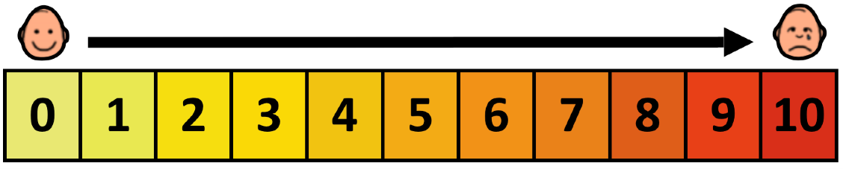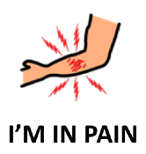

|  |  |  |  |
| --- | --- | --- | --- |
| **No Pain** | **Mild Pain** | **Moderate Pain** | **Intense Pain** |

|  |  |  |  |  |  |
| --- | --- | --- | --- | --- | --- |
| **HEAD** | **THROAT** | **CHEST** | **STOMACH** | **BACK** | **ARMS** |
| **HANDS** | **HIP** | **BACKSIDE** | **THIGH** | **LEGS** | **FEET** |
| **OTHER BODY PARTS** |  | **LEFT** | **RIGHT** | **UP** | **DOWN** |