我的 XX 痛

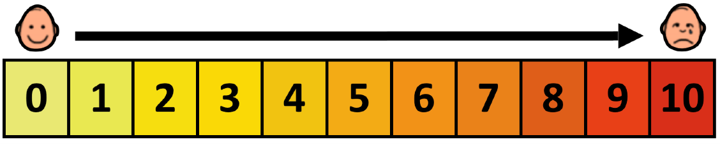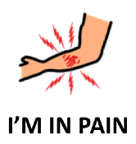

|  |  |  |  |
| --- | --- | --- | --- |
| **不痛No pain** | **轻微疼痛Mild** | **中度疼痛Moderate** | **极烈Intense** |

|  |  |  |  |  |  |
| --- | --- | --- | --- | --- | --- |
| **头 HEAD** | **喉咙 THROAT** | **胸部**  **CHEST** | **肚子**  **STOMACH** | **背部**  **BACK** | **手臂**  **ARMS** |
| **手**  **HANDS** | **臀部**  **HIP** | **屁股**  **BACKSIDE** | **大腿**  **THIGH** | **腿**  **LEGS** | **脚**  **FEET** |
| **其他身体部位**  **OTHER BODY PARTS** |  | **左LEFT** | **右RIGHT** | **上UP** | **下 DOWN** |