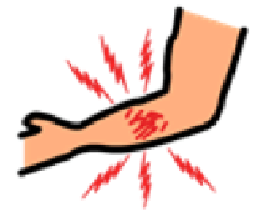  MAY MASAKIT  PAIN | NASUSUKA  NAUSEOUS | NASASAKAL AKO  CHOKING | 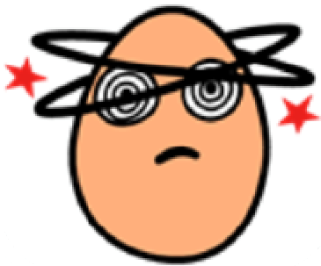  NAHIHILO AKO  DIZZY | PAGOD NA AKO  TIRED | 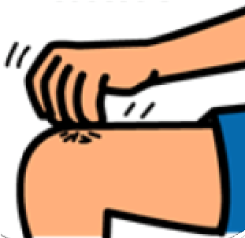  MAY MAKATI  ITCHY
NATATAKOT  AKO  I’M SCARED | 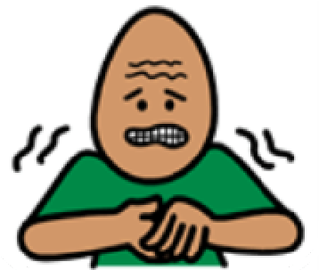  KINAKABAHAN  AKO  I’M NERVOUS | OKAY LANG AKO  I’M OKAY | INAANTOK AKO  I’M TIRED | GALIT AKO  I’M ANGRY | SALAMAT  THANK YOU
KAILANGAN KO NG DASAL  I NEED PRAYER | 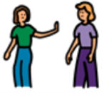  IWANAN MO  MUNA AKO  LEAVE ME ALONE | 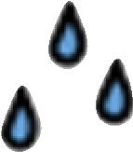  PINAGPAPAWISAN AKO  I’M SWEATY | TAWAGIN ANG  DOKTOR  CALL THE DOCTOR | TAWAGIN ANG NURSE  CALL THE NURSE | TAWAGAN ANG  PAMILYA KO  CALL MY FAMILY
YES  OO |  | I DON’T KNOW  HINDI KO ALAM |  | NO  HINDI

