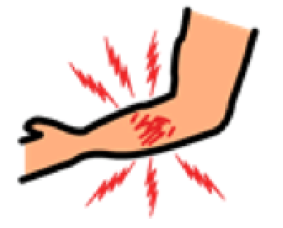  MAY MASAKIT  PAIN | MAY MAKATI  ITCHY | HINDI KA PWEDENG KUMAIN AT UMINOM  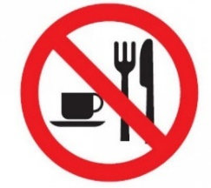  YOU CANNOT EAT OR DRINK | 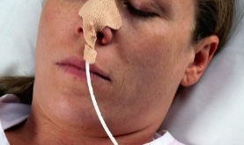  KAILANGAN MO NG FEEDING TUBE  YOU NEED A FEEDING TUBE | 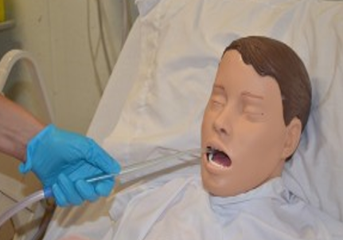SUCTION | 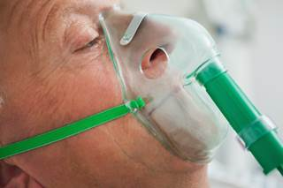OXYGEN
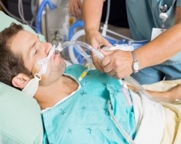 | KAILANGAN MO NG TUBO SA IYONG LALAMUNAN PARA IKAW AY MAKAHINGA  YOU NEED INTUBATION TO HELP YOU BREATHE | 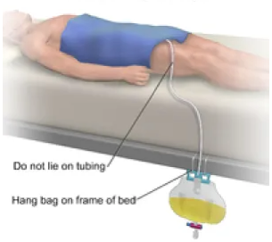 | KAILANGAN MO NG CATHETER  YOU NEED A URINARY CATHETER | 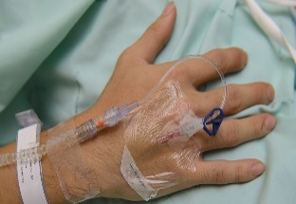 | KAILANGAN MO NG TUBO SA IYONG UGAT  YOU NEED A TUBE IN YOUR BLOOD VESSEL
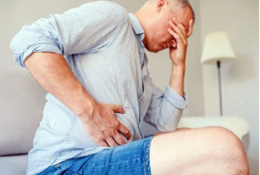  NAGTATAE / PANINIGAS NG DUMI  DIARRHEA/ CONSTIPATION | 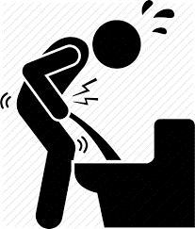  NAHIHIRAPANG UMIHI  DIFFICULTY PASSING URINE | 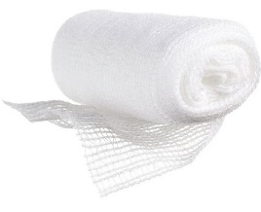  PALITAN ANG DRESSING  CHANGE DRESSING | BLOOD TEST | 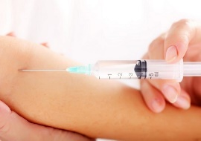INJECTION | 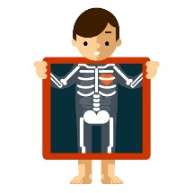  X-RAY
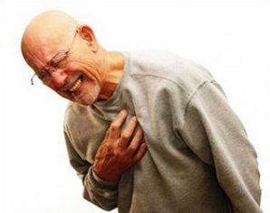  MERON KANG COVID  YOU HAVE COVID | 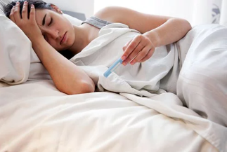  MERON KA BANG LAGNAT?  DO YOU HAVE A FEVER? | 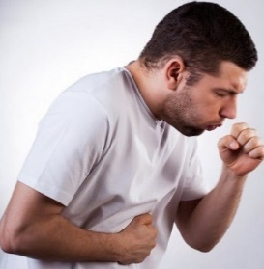  MERON KA BANG UBO?  DO YOU HAVE COUGH? | MERON KA BANG SIPON?  DO YOU HAVE A RUNNY NOSE? | 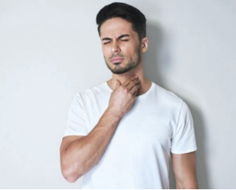  Meron ka bang pamamalat ng lalamunan o sore throat?  DO YOU HAVE A SORE THROAT? | NAHIHIRAPAN  AKO HUMINGA  ANY TROUBLE BREATHING?

