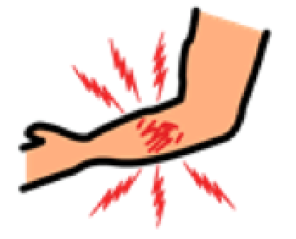  疼痛  PAIN | 痒  ITCHY | 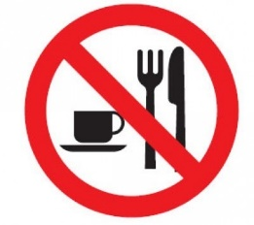  你不能吃和喝 YOU CANNOT EAT OR DRINK | 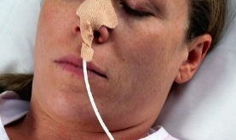  你需要放食管  YOU NEED A FEEDING TUBE | 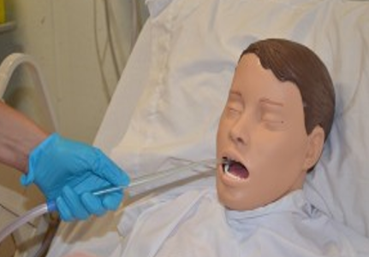 抽痰  SUCTION | 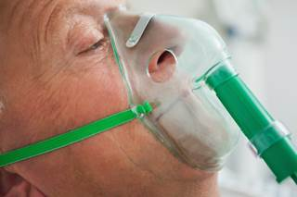 氧气支助  OXYGEN
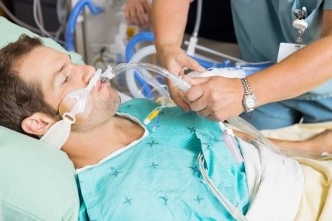 | 你需要插管协助你呼吸  YOU NEED INTUBATION TO GET OXYGEN IN YOUR LUNGS | 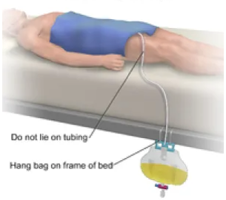 | 你需要使用导尿管  YOU NEED A TUBE IN YOUR BLOOD VESSEL | 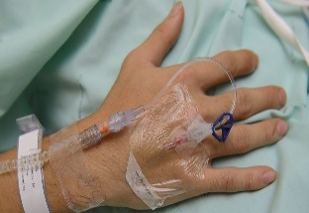 | 你需要插血管  YOU NEED A TUBE IN YOUR BLOOD VESSEL
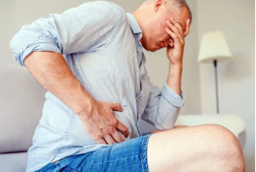  泻肚子/ 便秘  DIARRHEA/ CONSTIPATION | 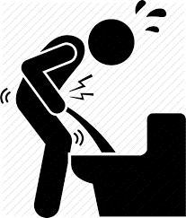  小便/排泄困难  DIFFICULTY PASSING URINE | 换药布  CHANGE DRESSING | 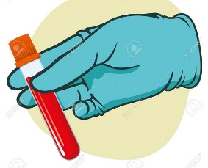  抽血/验血  BLOOD TEST | 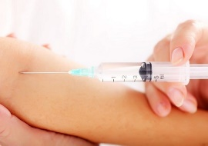  打针  INJECTION | 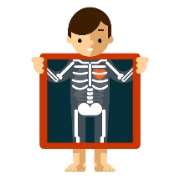  照X-光  X-RAY
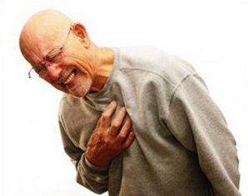你患上新冠肺炎  YOU HAVE COVID | 你有发烧吗？  DO YOU HAVE A FEVER? | 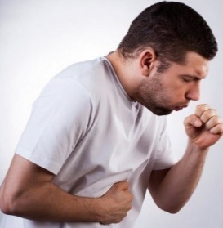  你有咳嗽吗?  DO YOU HAVE COUGH? | 你有流鼻涕吗?  DO YOU HAVE A RUNNY NOSE? | 你有喉咙痛吗?  DO YOU HAVE A SORE THROAT? | 你有呼吸困难吗?  ANY TROUBLE BREATHING
是  YES | 我不知道  I DON’T KNOW | 不是  NO

