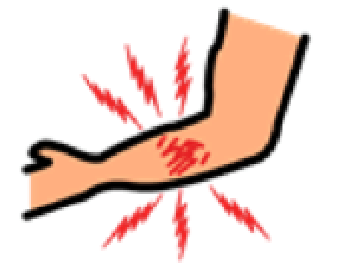  MAY MASAKIT  I’M IN PAIN | 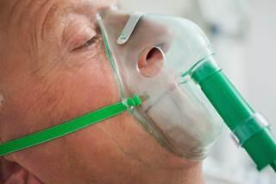OXYGEN | 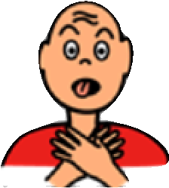NAHIHIRAPAN  AKO HUMINGA  TROUBLE BREATHING | 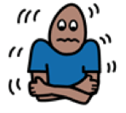  NILALAMIG AKO  I’M COLD | 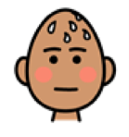  NAIINITAN AKO  I’M HOT | 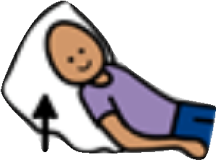  PAAYOS NG  POSISYON  ADJUST POSITION
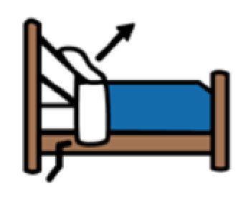  ITAAS ANG KAMA  ADJUST BED UP | 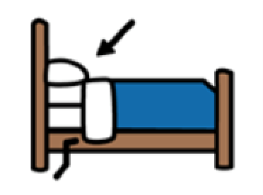IBABA ANG KAMA  ADJUST BED DOWN | 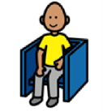  UPO  SIT DOWN | 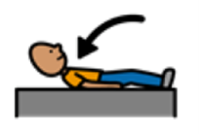  HIGA  LIE DOWN | GUTOM AKO  I’M HUNGRY | 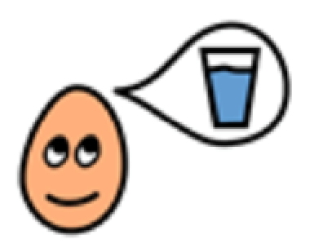  UHAW AKO  I’M THIRSTY
ON/OFF ANG ILAW  TURN LIGHTS  ON/ OFF | 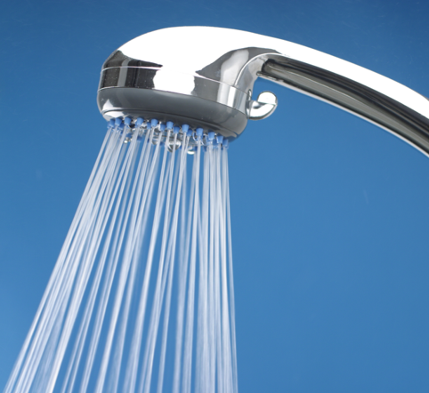  GUSTO KONG MALIGO  I WANT TO TAKE A BATH | 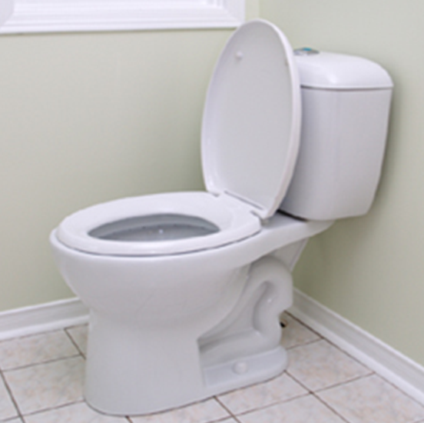  BANYO  TOILET | 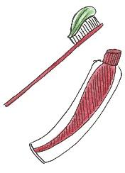  MAGSIPILYO  BRUSH TEETH | TAWAGIN ANG DOKTOR  CALL THE DOCTOR | 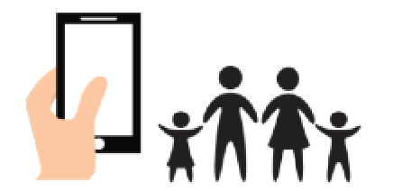  TAWAGAN ANG PAMILYA KO  CALL MY FAMILY
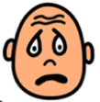  NATATAKOT AKO  I’M SCARED | ANONG PETSA/  ORAS NA?  WHAT DAY/  TIME IS IT? | 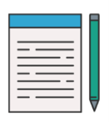  PAPEL AT BALLPEN  PEN & PAPER | 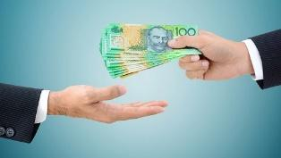  KAILANGAN KO BANG BAYARAN ITO?  DO I NEED TO PAY FOR THIS? | 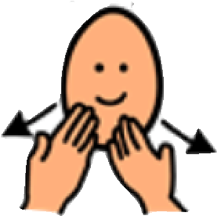  SALAMAT  THANK YOU

